Project: SkillSphere – AI-Driven Career Readiness and Personalized Learning Recommendation Platform
Scenario-Based Requirement Analysis

Submitted in the partial fulfilment for the Course of
CSA1012 – SOFTWARE ENGINEERING
to the award of the degree of
BACHELOR OF TECHNOLOGY
IN
COMPUTER SCIENCE(AI)
Submitted by
R.Jalaja (192525365)
Under the Supervision of
DR ANITADAVAMANI K
SIMATS ENGINEERING
Saveetha Institute of Medical and Technical Sciences
Chennai-602105
Aug -2026

- Introduction
  - Purpose
This Software Requirement Specification (SRS) document defines the functional and non-functional requirements of SkillSphere, an AI-driven career readiness and personalized learning recommendation platform.
SkillSphere is designed to address the gap between academic education and evolving industry requirements by analyzing student competencies, identifying skill deficiencies, recommending personalized learning resources, and predicting career suitability.
The platform integrates academic performance, technical skills, certifications, projects, career interests, skill assessments, and job-market information to develop a unified competency profile for each student. Based on this profile, the system generates personalized learning pathways and career-readiness insights.

1.2 Business Domain
SkillSphere operates within the following domains:
- Education Technology (EdTech)
- Artificial Intelligence and Machine Learning
- Career Guidance and Development
- Personalized Learning
- Skill Assessment
- Workforce and Employability Development

1.3 Stakeholders
The primary stakeholders identified for SkillSphere are:
Stakeholder | Role / Interest
Students | Primary users who require personalized career guidance and learning recommendations
Faculty / Educators | Monitor student progress and cohort-level skill readiness
Institution Administration | Uses career-readiness information to support institutional outcomes and placement initiatives
Product Owner | Defines product priorities and manages the product backlog
Scrum Master | Facilitates the Agile development process
Development Team | Designs, develops, tests, and maintains the platform
Recruiting Partners | Provide industry-related skill-demand information and benefit from better-prepared candidates

2. Problem Description
The rapid evolution of technology has created a significant gap between academic education and the skills demanded by modern industries. Students may graduate with adequate theoretical knowledge but lack practical skills, certifications, project experience, and other competencies required for employment.
Traditional Learning Management Systems generally provide standardized learning content and do not sufficiently adapt to individual student strengths, weaknesses, career interests, or changing industry requirements.
The major challenges identified for SkillSphere include:
- Static curriculum structures that may not keep pace with changing industry requirements.
- One-size-fits-all learning approaches.
- Fragmented information relating to academic performance, certifications, and projects.
- Limited predictive career guidance.
- Insufficient integration with current job-market skill requirements.
As a result, students may have difficulty identifying suitable career paths and determining the specific competencies they need to develop. SkillSphere is proposed to address these limitations through AI-based skill-gap analysis, personalized recommendations, and career-suitability prediction.

3. Objectives of the System
The objectives of SkillSphere are:
- To develop an AI-powered platform for career-readiness assessment and personalized learning.
- To analyze students' academic performance, technical skills, certifications, projects, and career interests.
- To identify skill gaps based on target-role requirements and industry trends.
- To recommend personalized courses, certifications, learning resources, and practical projects.
- To predict career-track suitability using machine-learning and competency analysis.
- To provide dashboards for students and educators to monitor progress.
- To incorporate job-market analytics and industry skill-demand information.
- To support continuous AI-driven career guidance and employability improvement.

4. Scope of the System
4.1 In-Scope
The proposed SkillSphere platform includes:
- Student profile management
- Academic record management
- Certification management
- Skill and project information
- Career-interest selection
- Competency profile generation
- Skill-gap analysis
- Personalized learning recommendations
- Course and certification recommendations
- Practical project recommendations
- Career-suitability prediction
- Student progress tracking
- Educator dashboards
- Cohort-level skill-gap monitoring
- Job-market skill-demand analysis
- Continuous recommendation updates
4.2 Out-of-Scope
The following activities are outside the primary scope of the proposed platform:
- Direct recruitment or job placement
- Issuing official academic or professional certifications
- Conducting university examinations
- Replacing institutional academic evaluation
- Guaranteeing employment
- Making final recruitment decisions on behalf of employers

5. Existing System Analysis
Traditional Learning Management Systems and generic career-guidance platforms provide useful educational and career-related services. However, they have limitations when personalized, industry-aligned career development is required.
Capability | Existing System | SkillSphere
Content Delivery | Generally standardized | Personalized according to skill gaps
Skill Assessment | Primarily academic/course based | Multi-source competency assessment
Career Guidance | Manual or periodic | AI-driven and continuously updated
Industry Alignment | Limited/static | Job-market information integrated
Progress Monitoring | Conventional grade reports | Interactive progress dashboards
Recommendations | General learning content | Personalized courses, projects and certifications
The proposed SkillSphere system addresses the specific gap between conventional content delivery and personalized, market-aware career guidance.

6. Proposed System
SkillSphere is proposed as a modular, AI-enabled platform that integrates student information with industry skill requirements.
The overall processing flow is:
Academic Records
Certifications
Skill Assessments
Projects
Career Interests
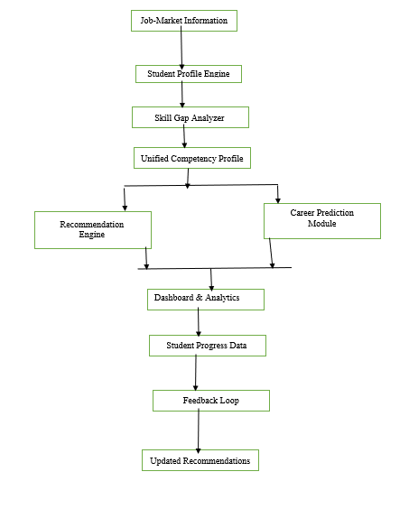

7. Functional Requirements
FR-01: User Authentication
The system shall provide secure authentication for authorized users.
The system shall support role-based access for relevant users such as students, educators, and administrators.
FR-02: Student Profile Management
The system shall allow students to create and maintain their competency profiles.
Students shall be able to:
- Add academic information.
- Add technical skills.
- Add project information.
- Add certifications.
- Specify career interests.
- Update their information when new competencies are acquired.
FR-03: Academic Record and Certification Upload
The system shall allow students to upload supported academic transcripts and certification documents.
The system shall:
- Validate uploaded files.
- Reject unsupported formats.
- Parse supported information.
- Store the extracted information.
- Provide confirmation after successful processing.
The Sprint 1 acceptance criteria specify support for PDF/CSV transcript uploads and processing within 10 seconds under the stated scenario.
FR-04: Career-Interest Management
The system shall allow students to select one or more career interests from the available career-track options.
The selected career interests shall be stored in the student's profile and used to personalize subsequent analysis and recommendations.
FR-05: Competency Profile Generation
The system shall consolidate relevant student information into a unified competency profile.
The competency profile shall consider, where available:
- Academic performance
- Technical skills
- Certifications
- Projects
- Skill assessments
- Career interests
FR-06: Skill-Gap Analysis
The system shall compare the student's competency profile with the requirements associated with the selected target career.
The system shall:
- Identify missing or insufficient competencies.
- Calculate a skill-gap score.
- Prioritize identified gaps.
- Display the ranked skill gaps to the student.
The Agile specification requires the Skill Gap page to display a ranked list with a numeric priority score.
FR-07: Personalized Learning Recommendations
The system shall recommend learning resources based on identified skill gaps.
Recommendations may include:
- Courses
- Learning resources
- Certifications
- Practical projects
The recommendations shall be ranked according to their relevance to the identified competency gaps.
FR-08: Recommendation Re-Evaluation
The system shall update recommendations when the student's competency information changes.
When a student completes a recommended learning activity, the corresponding competency information shall be updated and recommendations shall be re-ranked.
FR-09: Career Suitability Prediction
The system shall predict the student's suitability for relevant career tracks using machine-learning classification techniques.
The research identifies Random Forest, Gradient Boosting, and Logistic Regression as possible classification approaches.
FR-10: Student Dashboard
The system shall provide students with a dashboard containing:
- Competency profile
- Career interests
- Skill-gap results
- Recommended learning activities
- Completed activities
- Learning progress
- Career-suitability results
FR-11: Educator Dashboard
The system shall provide educators with appropriate monitoring capabilities, including:
- Student progress
- Aggregated skill-gap information
- Cohort-level readiness
- Common competency deficiencies
FR-12: Job-Market Analytics
The system shall incorporate job-market information to identify relevant skills associated with target career roles.
Where applicable, the system shall support analysis of emerging industry skill requirements.
FR-13: Skill Extraction Using NLP
Where applicable, the system shall support extraction of relevant skills from textual sources such as:
- Resumes
- Certificates
- Job descriptions
The research identifies Named Entity Recognition and embeddings as possible NLP approaches.

8. Non-Functional Requirements
8.1 Performance
- The system shall provide timely responses to user requests.
- Supported student documents shall be processed within the defined performance threshold.
- Skill-gap and recommendation results shall be generated within an acceptable response time.
- Under the Sprint 1 scenario, supported transcript data shall be processed within 10 seconds.
8.2 Security
- The system shall authenticate authorized users.
- Access shall be controlled according to user roles.
- Student information shall be protected from unauthorized access.
- Sensitive academic and personal information shall be securely stored and transmitted.
8.3 Privacy
- Appropriate consent shall be obtained before processing student information.
- Access to personal and academic information shall be restricted.
- The system shall consider privacy requirements when handling student data.
Data privacy and consent management are identified as significant challenges in the SkillSphere research.
8.4 Usability
- The system shall provide a simple and intuitive interface.
- Skill gaps shall be presented clearly.
- Recommendations shall be understandable and traceable to identified gaps.
- Dashboards shall present information in a user-friendly manner.
8.5 Reliability
- The system shall maintain the integrity of student records.
- Data updates shall not result in unintended loss of information.
- The system shall provide meaningful error messages.
- Recommendation and prediction services should operate consistently.
8.6 Scalability
The system shall be designed to support growth in:
- Student population
- Educator users
- Career tracks
- Learning resources
- Job-market information
- Institutional deployment
The research identifies scalability as an intended characteristic of SkillSphere.
8.7 Maintainability
The platform shall follow a modular architecture so that individual components can be modified, tested, and maintained independently.
8.8 Availability
The platform should remain available to authorized users during normal operating periods, excluding scheduled maintenance.

9. Actors and Use Cases
9.1 Primary Actors
Student
The student is the primary actor.
Major interactions include:
- Register/Login
- Create Profile
- Upload Academic Records
- Upload Certifications
- Add Skills and Projects
- Select Career Interest
- View Skill Gaps
- View Recommendations
- Complete Learning Activities
- View Career Prediction
- Monitor Progress
Educator
The educator acts as a secondary institutional user who monitors student and cohort-level readiness.
Major interactions include:
- View Student Progress
- View Skill Gaps
- View Cohort Analytics
- Monitor Career Readiness
9.2 Secondary Actors
Administrator
Responsible for system-level management and configuration.
Recruiting Partners
Provide industry-relevant skill-demand information.
External Job-Market Data Sources
Provide job postings and skill-demand information for analysis.

10. Use Case Catalogue
Use Case ID | Use Case | Primary Actor
UC-01 | Register / Login | Student
UC-02 | Manage Student Profile | Student
UC-03 | Upload Transcript / Certification | Student
UC-04 | Specify Career Interest | Student
UC-05 | Generate Competency Profile | Student / System
UC-06 | Analyze Skill Gaps | Student
UC-07 | View Personalized Recommendations | Student
UC-08 | Update Learning Progress | Student
UC-09 | Predict Career Suitability | Student
UC-10 | View Student Dashboard | Student
UC-11 | View Cohort Dashboard | Educator
UC-12 | Monitor Student Skill Gaps | Educator
UC-13 | Manage System Information | Administrator
UC-14 | Provide Industry Skill Data | Recruiting Partner

11. Use Case Diagram
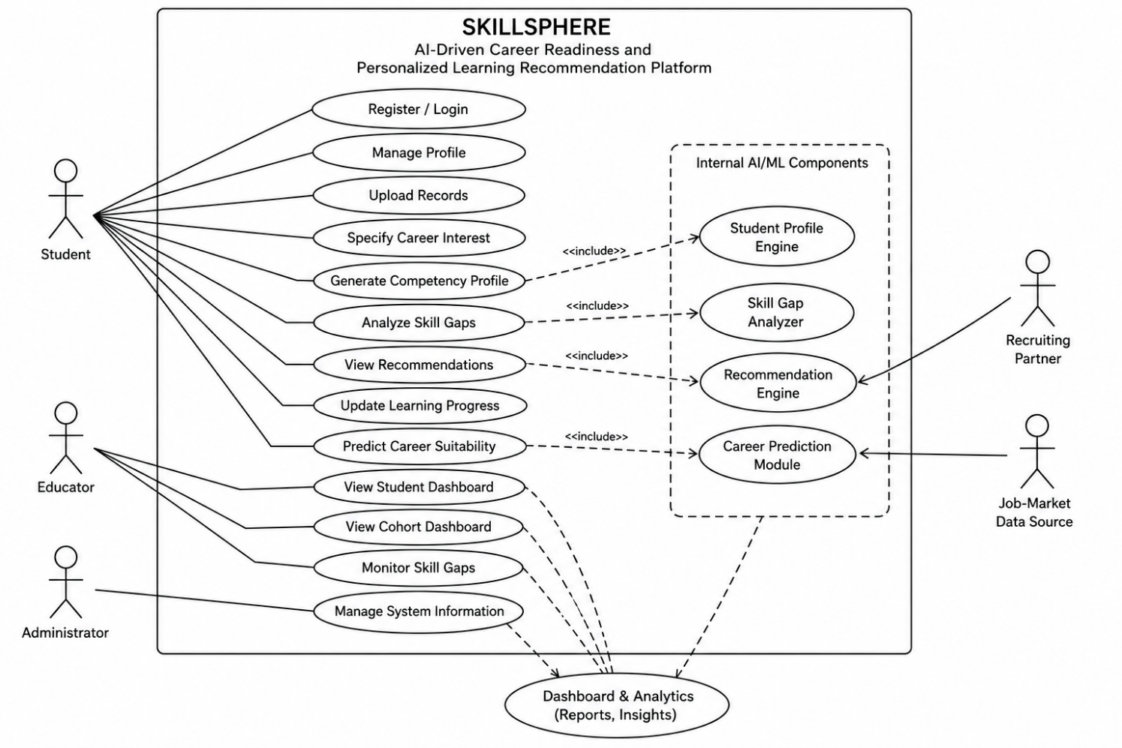
12. Detailed Use Case Descriptions
UC-01: Register / Login
Actor: Student
Precondition: The user has access to the SkillSphere platform.
Main Flow:
- User opens the authentication page.
- User enters valid credentials.
- System verifies the credentials.
- System authenticates the user.
- System provides access according to the user's role.
Postcondition: The authenticated user accesses the appropriate dashboard.

UC-02: Manage Student Profile
Actor: Student
Precondition: Student is authenticated.
Main Flow:
- Student opens the profile section.
- Student enters or updates relevant information.
- Student submits the information.
- System validates the input.
- System stores the updated information.
- Competency information becomes available for subsequent analysis.
Postcondition: Student profile is updated.

UC-03: Upload Transcript / Certification
Actor: Student
Precondition: Student is logged in.
Main Flow:
- Student selects the upload option.
- Student selects a supported file.
- System validates the file.
- System processes the file.
- Relevant information is stored.
- System displays a confirmation message.
Alternative Flow:
If an unsupported file is submitted, the system rejects it and displays an appropriate error message.

UC-04: Specify Career Interest
Actor: Student
Precondition: Student is logged in.
Main Flow:
- Student opens the career-interest section.
- System displays available career tracks.
- Student selects one or more career interests.
- System stores the selection.
- System displays the selected career interest in the profile.
Postcondition: Career interest is available for skill-gap analysis and recommendations.

UC-05: Analyze Skill Gaps
Actor: Student
Precondition: Student profile and target career information are available.
Main Flow:
- Student opens the Skill Gap page.
- System retrieves the student's competency information.
- System retrieves target-role requirements.
- System compares competencies against requirements.
- System calculates skill gaps.
- System assigns priority scores.
- System ranks the identified gaps.
- System displays the results.
Postcondition: Student receives a prioritized skill-gap report.

UC-06: View Personalized Recommendations
Actor: Student
Precondition: At least one skill gap has been identified.
Main Flow:
- Student opens the Recommendations page.
- System identifies priority skill gaps.
- Recommendation Engine searches the learning-resource catalogue.
- Relevant resources are ranked.
- System displays courses, projects, and certifications mapped to the gaps.
Postcondition: Student receives a personalized learning pathway.

UC-07: Predict Career Suitability
Actor: Student
Precondition: Student competency information is available.
Main Flow:
- Student requests career prediction.
- System constructs the competency representation.
- ML model processes the information.
- System calculates career suitability.
- System displays the results.
Postcondition: Student receives career-suitability information.

UC-08: Update Learning Progress
Actor: Student
Precondition: Student has an existing recommendation.
Main Flow:
- Student completes a recommended activity.
- Student records the completion.
- System updates progress.
- Relevant competency information is updated.
- Skill-gap analysis is re-evaluated.
- Recommendations are re-ranked.
This represents the continuous feedback loop described in the SkillSphere architecture.

UC-09: Monitor Cohort Readiness
Actor: Educator
Precondition: Educator is authenticated and has appropriate access.
Main Flow:
- Educator opens the cohort dashboard.
- System retrieves relevant student data.
- System aggregates skill-gap and progress information.
- System displays cohort-level readiness information.
Postcondition: Educator can identify common skill gaps and monitor student readiness.

13. Data Requirements
SkillSphere requires structured data for the following entities:
Student
- Student ID
- Name
- Academic information
- Career interests
- Skills
- Projects
- Certifications
Skill
- Skill ID
- Skill name
- Skill level
- Student association
Career Track
- Career ID
- Career name
- Career description
- Required skills
Learning Resource
- Resource ID
- Resource name
- Resource type
- Associated skill
- Difficulty level
- Provider
Skill Gap
- Student ID
- Career ID
- Skill ID
- Current competency
- Required competency
- Gap score
- Priority
Recommendation
- Student ID
- Resource ID
- Associated skill gap
- Recommendation score
- Status
Job-Market Information
- Job role
- Required skill
- Skill demand
- Industry
- Relevant market information
Career Prediction
- Student ID
- Career track
- Suitability score
- Prediction date

14. External Interface Requirements
14.1 User Interface
The system shall provide user interfaces for:
- Authentication
- Student profile management
- Document upload
- Career-interest selection
- Skill-gap analysis
- Learning recommendations
- Career prediction
- Student progress
- Educator dashboards
14.2 Software Interfaces
The system may interact with:
- Institutional academic databases
- Learning-resource repositories
- Job-market data sources
- AI/ML services
- Recommendation services
- NLP components
14.3 Hardware Interfaces
The platform shall be accessible using standard:
- Desktop computers
- Laptops
- Tablets
- Smartphones
No specialized hardware is required for the core system.
14.4 Communication Interfaces
The system shall support secure communication between:
- Client application
- Application server
- Database
- AI/ML services
- External data sources

15. AI and Machine-Learning Requirements
The proposed AI/ML components include:

Technique | Application
Content-Based Filtering | Match learning resources with identified skill gaps
Collaborative Filtering | Use outcomes from similar student profiles
Random Forest | Career suitability classification
Gradient Boosting | Career suitability classification
Logistic Regression | Career suitability classification
Named Entity Recognition | Extract skills from textual documents
Embeddings | Represent and compare textual/skill information
K-Means | Group students with similar skill profiles
Hierarchical Clustering | Cohort-level skill analysis
ARIMA | Forecast industry skill demand
LSTM | Forecast emerging skill trends
These approaches are based on the techniques identified in the original SkillSphere research.

16. System Architecture Requirements
The system shall follow a modular architecture consisting of:
Layer 1: Data-Ingestion Layer
Collects:
- Academic records
- Certifications
- Skills
- Projects
- Career interests
- Skill assessments
- Job-market information
Layer 2: AI/ML Processing Layer
Contains:
- Student Profile Engine
- Skill Gap Analyzer
- Recommendation Engine
- Career Prediction Module
- NLP processing
- Job-market analytics
Layer 3: Presentation Layer
Provides:
- Student dashboard
- Educator dashboard
- Skill-gap reports
- Recommendations
- Career-suitability results
Layer 4: Feedback Mechanism
Uses student progress to update the competency profile and future recommendations.

17. Assumptions
The following assumptions apply:
- Students provide accurate and valid information.
- Uploaded documents are readable and supported.
- Students provide meaningful career interests.
- Required industry skill information is available.
- Job-market information is sufficiently current.
- Suitable learning resources are available for identified skill gaps.
- Historical data is available where required for ML model development.
- Users have reliable internet access.
- Students and educators have authorized accounts.
- Appropriate student consent is obtained before processing personal or academic data.

18. Constraints
18.1 Technical Constraints
- Model performance depends on the quality and quantity of available training data.
- NLP-based extraction may not always be completely accurate.
- External job-market data may be incomplete or unavailable.
- Integration with institutional systems may require additional development.
18.2 Operational Constraints
- Students must maintain updated profiles for accurate recommendations.
- Educators require appropriate authorization to access student information.
- Recommendation quality depends on available learning resources.
18.3 Economic Constraints
- Cloud infrastructure may incur operational costs.
- External data sources may require subscription or integration costs.
- AI/ML processing may require additional computational resources.
18.4 Legal and Privacy Constraints
- Student academic and personal data must be protected.
- Appropriate consent must be obtained.
- Unauthorized access must be prevented.
- AI-based recommendations should be monitored for fairness and bias.
These concerns are consistent with the challenges identified in the SkillSphere research, particularly privacy, consent, fairness, job-market data quality, and institutional integration.
18.5 Time Constraints
The initial implementation is planned using an Agile development approach. Sprint 1 is defined as a two-week sprint focusing on profile creation, career-interest selection, skill-gap analysis, and personalized recommendations.

19. Requirement Validation
19.1 Completeness
The SRS covers the principal requirements identified in the project:
- Student profile management
- Career-interest selection
- Skill-gap analysis
- Personalized recommendations
- Career prediction
- Student progress monitoring
- Educator monitoring
- Job-market analysis
These requirements correspond with the five project epics identified in the Agile planning document.
19.2 Consistency
The requirements are consistent with the overall SkillSphere architecture and Agile backlog.
The major relationship is:
E1 → Student Profile Management
E2 → Skill Gap Analysis
E3 → Personalized Recommendations
E4 → Career Prediction
E5 → Dashboards & Reporting
19.3 Ambiguity
Requirements should be measurable wherever possible.
For example:
Ambiguous Requirement:
The system shall process uploaded files quickly.
Improved Requirement:
The system shall parse and store a supported transcript within 10 seconds under the specified Sprint 1 scenario.
The second version is measurable and testable.
19.4 Redundancy
Student competency information should be maintained through a unified profile rather than duplicated across multiple independent modules.
19.5 Missing Requirements
The following areas require further specification during detailed system design:
- Exact skill-gap scoring methodology.
- Training dataset and data-preparation process.
- ML model evaluation criteria.
- Recommendation evaluation methodology.
- Job-market data source and update frequency.
- Data-retention policies.
- Backup and recovery procedures.
- Detailed administrator functions.
- Model fairness and bias evaluation procedures.
These aspects are not fully specified in the supplied research documents and should therefore be defined during subsequent design and implementation phases.

20. Requirement Traceability Matrix
Objective | Related Requirement | Actor
Assess career readiness | FR-05: Competency Profile | Student
Identify skill gaps | FR-06: Skill-Gap Analysis | Student
Provide personalized learning | FR-07: Recommendations | Student
Update recommendations | FR-08: Recommendation Re-evaluation | Student/System
Predict career suitability | FR-09: Career Prediction | Student
Track progress | FR-10: Student Dashboard | Student
Monitor students | FR-11: Educator Dashboard | Educator
Analyze industry requirements | FR-12: Job-Market Analytics | System / Industry
Extract skills from documents | FR-13: NLP Skill Extraction | System

21. Recommendations for Requirement Improvement
To improve the quality, completeness, and testability of the SRS, the following enhancements are recommended:
- Define a formal mathematical model for skill-gap scoring.
- Specify the exact dataset structure required for career prediction.
- Define measurable ML performance targets.
- Define recommendation-quality evaluation metrics.
- Specify the source and update mechanism for job-market data.
- Define detailed data privacy and consent procedures.
- Establish role-based access-control requirements.
- Define data backup and recovery requirements.
- Specify model fairness and bias evaluation criteria.
- Define a clear procedure for validating predictions against actual placement outcomes.
The Agile document already identifies tracking prediction accuracy against real placement outcomes as a future requirement.

22. Conclusion
The Software Requirement Specification for SkillSphere: AI-Driven Career Readiness and Personalized Learning Recommendation Platform defines a structured approach for addressing the gap between academic learning and industry skill requirements.
The proposed system integrates student academic records, technical skills, certifications, projects, career interests, skill assessments, and job-market information to construct a unified competency profile. The Skill Gap Analyzer compares this profile with target-career requirements and identifies prioritized competency gaps.
The Recommendation Engine then provides personalized learning resources, courses, certifications, and practical projects. The Career Prediction Module provides career-suitability insights using machine-learning techniques, while student and educator dashboards support continuous monitoring of progress.
A feedback mechanism allows the platform to update student competency information and refine future recommendations as students acquire new skills.
The SRS identifies the major functional and non-functional requirements, stakeholders, actors, use cases, data requirements, interfaces, system features, assumptions, constraints, and validation criteria. Therefore, this specification provides a structured foundation for the subsequent design, development, testing, and deployment of the SkillSphere platform.

